Torque Calculation for 6 kg Robot on Tiles
Estimating the required torque for robot’s displacement to be close to human pace while tracking, we used:
• Mass m = 6 kg
• Ground: flat terrain
• Number of driven wheels = 2
• Wheel radius r = 0.065 m (130 mm diameter)
• Chosen linear acceleration a ≈ 0.3 m/s²

1. Acceleration force:
$F_acc = m · a$ = 6 × 0.3 = 1.8 N

2. Rolling resistance on tiles (C_rr ≈ 0.02):
$$F_rr = C_rr · m · g = 0.02 × 6 × 9.81 ≈ 1.18 N$$
3. Total drive force:
$$F_total ≈ F_acc + F_rr ≈ 1.8 + 1.18 ≈ 3.0 N$$

4. Torque at the wheels:
$$T_total = F_total · r = 3.0 × 0.065 ≈ 0.195 N·m$$

5. Torque per motor (with 2 driven wheels):
$$T_per_motor ≈ T_total / 2 ≈ 0.195 / 2 ≈ 0.0975 N·m ≈ 0.1 N·m$$

Therefore, each motor should be able to provide about 0.1 N·m of continuous torque. For this, we selected the motors with a safety factor of around 2, this value as stall torque to ensure a safe margin.
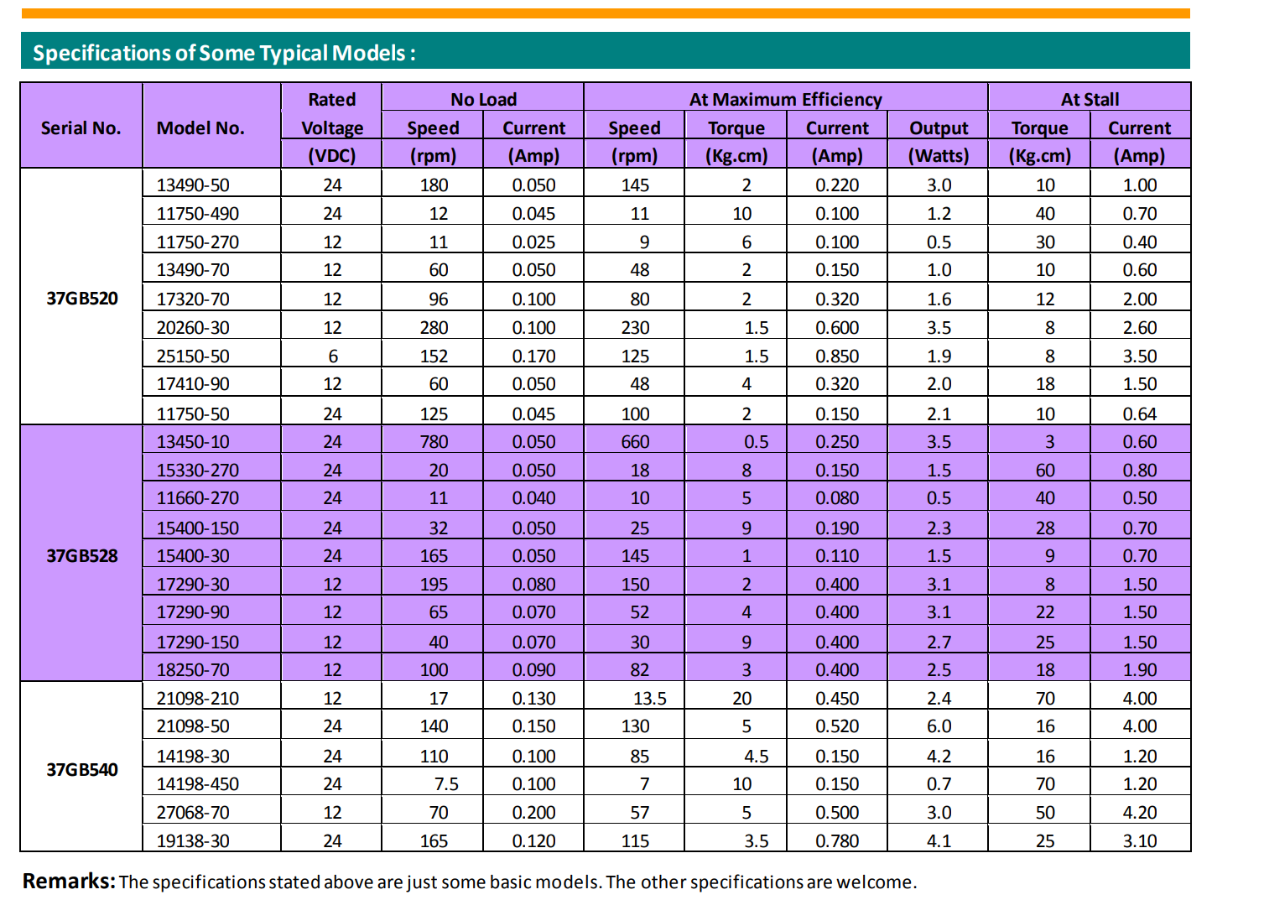

PWM duty (d) | Approx. torque (T(d))
30% | 0.059 N·m
40% | 0.078 N·m
50% | 0.098 N·m (just below required)
60% | 0.118 N·m
70% | 0.137 N·m
80% | 0.157 N·m
90% | 0.176 N·m
100% | 0.196 N·m

We need around 0.1N.m

